Mobhaile Portal Design Document: Draft
element.
' BGCOLOR=color_yalue | 0 | Hexidecimal red-blue-green color value for the map's background color. Default is OxFFFFFF (white).
TRANSPARENT=true | false | 0 | Map's background transparency. Default is false.
SLD=sld_url | 0 | URL of a styled layer descriptor file. See WMS SLD-enabled GetMap operation for details.
For example.
http://gplan/map.aspx?version=l.l.l&request=::getmap&SRS=::EPSG:4326&BBox=-97.105,24.913,78.794,36.358&width=560&Height=350&Layers-Discovery&Styles-0X FF8080&Format=image/png&BGColor=0xFFFFFF&Transparent=True
GetFeaturelnfo
Optional. Ask for information about features displayed in the map.
Shown is the flow of information from the Mobhaile Client to the WMS servers for gPlan and Mobhaile.
The user will login to the mobhaile portal. The portal will check the Bounding Box to which they are associated. That is, check the location to which they have associated themselves and then build a bounding box of XX metres around this point.
This bounding box will then be passed the WMS which are being used. PNGs will then be passed back to the Client where these will be combined into one single PNG.
Each PNG will have attributes behind each object on the map. Each object will contain
- The unique feature ID
- A tooltip from the server
- An event hotspot which can be fired
- Details of originating server.
Page 21 of 34
Mobhaiie Portal Design Document: Draft

Oetcapabilities
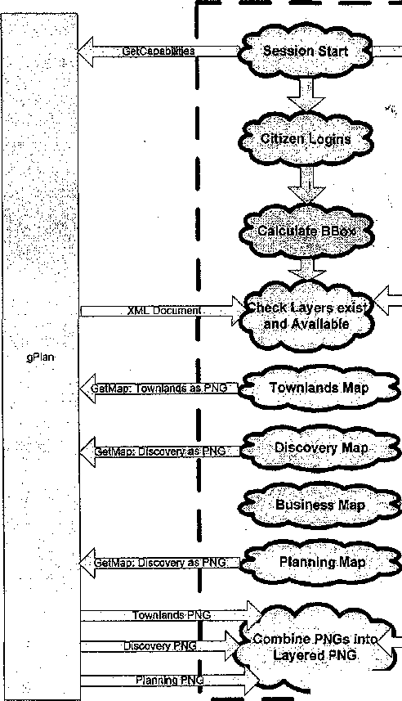
TGii

ML Document
JS
Map Business as PNG)
3uslnessPNG
mobhaiie

Mobhaiie Portal Design Document: Draft
7. Digitising web Service
A generic web service will need to be created to enable the creation of features into the database. The Web service will initially only allow the digitising of points on-line.The web service will be sitting as a service wrapped around the GIS database it is communicating with. This GIS database will have multiple GIS datasets associated with it. These will be different layers in the output map.
Digitising web Service


GIS Database

Shown is the flow for the web service.

Client Application
User Enters Altrfbutes i

Clicks on Map (o Enter Point
'Success or Error Report

7\
Parameters :-
LayerName
ID
X Co-Ordinate
Y Co-ordinate

r
17
Sat Access Rights
3E
Conned To.Database

Connect to Table: Layname
Digitising Web Service

Check HID exists
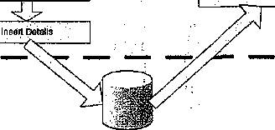
ss:
Create Row for ID:
Success or Error

Page 23 of 34

Mobhaile Portal Design Document: Draft
An example would be the digitising of a Business Feature. The Parameters passed would be Layername="Business", ID^'GUID" from ADAM, X and Y coordinates of Business object. Webservice would have details of Access rights and database to connect to. Web service would then connect to Mobhaile Business table in Mobhaile iGIS database. Check that this ID does not already exist, create a row and insert ID and point object associated with the business.
Page 24 of 34
Mobhaile Portal Design Document: Draft
8. Business Functionality
There will be functionality associated with businesses.
Reporting
The Portal user will have the ability to click on a category which will then display all sub-categories associated with this category. The user can then click on the sub-category and view all businesses associated with- this sub-category. The user can then click on a business and view the details. At this point the portal user can click on a button and locate the business on the map.
At any point on the map the user can click on a Business object and view the details associated with this object.
This reporting on Businesses will be required to be a generic tool. This is required when the information associated with a spatial object is stored in a separate database
So when a User clicks on an object on the Map the following happens
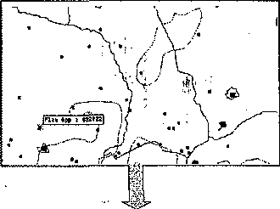
User Clicks on Object in Map
-<,
Dataset Name Eind Object ID is Determined
Dataset Name and Object ID is Passed to j
Reporting Web Service '
W ,
Attributes extracted and generated ,
Dataset information displayed to the Citizen
Page 25 of 34
Mobhaile Portal Design Document: Draft

r
Click on Object on MªP
Client Application

Determine Originating GIS Server
Z2d
Delerrnlne.:Layer Name
Display XML

1Z
.Determine ID.
Formulate XML

Parameters :-Layer Name ID
XML Results

r
'ConhecitoIGlS: Database.
3E
Connect to]Table: Layname
2^.
Check if ID.exists
Reporting Web Service

Check Attribute Object
Attibutes Exist

AE
Check webseryice Object
Output Results as XML

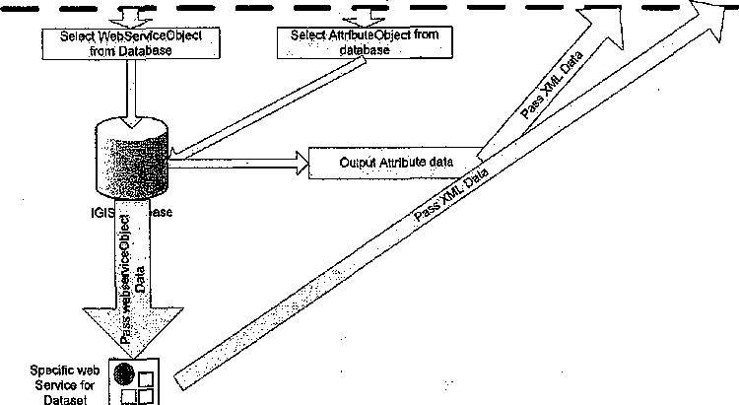
When the user clicks on an object on the map the client application will determine the originating server, layer and id of the feature. This will then be passed to the Reporting Web service. This will query the appropriate server , layer and id. The web service will check if there are attributes stored in the GIS database for the object residing in the
Page 26 of 34

Mobhaile Portal Design Document: Draft

AttributeObject. If there are attributes then these are passed back to the client Application as XML where they are transformed to be viewed by the user. If the Attributeobject does not contain any attributes then the webserviceobject is checked. The database will then pass the webserviceobject to the "Reporting Web service" which will then call the "Specific Web service" and accept XML as the resulting dataset. This XML will be passed to the "Reporting Web service" which will then be passed to the Client Application to be transformed as required.
For each Attribute database a web service will be required that will extract the selected
data and pass this back to the client. ' V
In this case the Business database will require a web service which will output the business information as XML.
If the Attribute information is stored in the same database as the Spatial feature then
Adding an event
As part of editing the profile of a business the business owner will have the ability to add an event and associate it to a business. The owner can set the day or range of days that the event occurs. For example every Monday or every Monday to Thursday. The business owner alternatively could set the date when the event is occurring. A Time, description and expiry date will also be associated with the Event. This functionality will be coded through the Business Web service.
Hillnn Hotrl Add New Emit i
3
I
J
i i
gut) mt | Rii.il |
Search for an event
Through the Portal a user can search by event time through all businesses and display the current events and associated businesses for the selected time and date. This functionality will be coded through the Business web service,
Page 27 of 34

Mobhaile Portal Design Document: Draft
i 111 ii) 'or
The user can search by Month, day and/or time range.
Find Nearest Business
When a Portal user has registered, designated a location to which they are associated to and then logged in, they will have the capability to find businesses in the local area.
Find Neaiest Bu^mes«c*
M.I I I I . 1 I
Find Nearest Web Service
The "Find Nearest" functionality will be generic across Mobhaile and other applications.
The functionality associated to this should be created as a web service which is generic.
The web service would accept Parameters of Layername, X,Y centroid, Buffer Distance
and field to search by.
These parameters would then be used to search the Attribute database and filter by field
to search by. The next step would be to perform a spatial query and return the results
within the requested buffer.
The results would be returned as an XML document to be transformed as required by the
client.
Page 28 of 34
Mobhaile Portal Design Document: Draft

r

Click on "Find Nearest" ■
i£
Determine Secondary Category
^
Determine Citizens X,Y
Client Application
-JDJspta^XMii.
■Fbrinulafe'XML'.

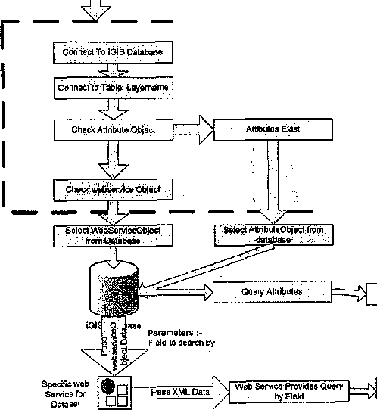
Parameters :-
Para maters :■
LayerName
X.V Centrold to search by
Field to seafch by
3g(fer Distance
Find Nearest Web Service

QutputAttribule data
Output Attribute data
LayertJame
10

output Resiiiis
i^
FindData.withinXX-meires . ofX,Ysupplied,by!Js«r
Attribute Data us; ed to Que ry a'flal nst <G1S -/■■"■bbjeets. ".'.■ ■'

10) Public Buildings
A dataset would be useful in the initial phase of the Mobhaile Portal would be the "Public Buildings" dataset. The tasks required for this are.
- SQL database designed using Corporate GIS structure - stored on the Mobhaile server
- Attributes agreed on
- Public Buildings digitised using
o Mapinfo OR o Geomedia OR o Geomedia webmap
- WMS entry designed for the Public Building
- Reporting designed for Public Building
Page 29 of 34

Mobhaile Portal Design Document: Draft
Appendix 1: Main Categories
- Entertainment
- Tourism & Recreation
- Education & Training
- Children's Issues
- Personal to Community
- Finance
- Domestic Services
- Support Services
- Employment
- Transport
- Commercial/Retail
- Social Services
- Housing
- Health '^{J}
Mobhaile Portal Design Document: Draft
Appendix 2 : Secondary Categories
- Bank
- Betting office
- Bus stop
- Business park
- car park
- Car sales repairs
- Coal suppliers
- Community Centre
- Credit Union
- Cycle shop
- Derelict site
- Dumping blackspot
- Garage
- Garden Centre
- Halting Site
- Health Centre
- Historic Site
- Industrial Estate
- Newsagent
- Post Office
- Public House
- Public Park
- School
- Service station
- Shopping Centre
- Shops
- Snooker club
- Sports centre
- Sports club
- Supermarket
- takeaway
- Traveller site
- Video shop
- Bakery
- Cinema
- Restaurants
- Off-Licence
- Internet Cafes
- FAS
- Adult Education
Page 31 of 34
Mobhaile Portal Design Document: Draft
Hotels
Libraries
Taxi
Support
Photography
Auctioneer
Doctors
Motor Tax
Social Welfare Office
ESB
Online Learning
Alcoholics Anonymous
Gamblers Anonymous
Employment Services
Residents Association
Community Development
Creche
Solicitor
Sports Ground
Page 32 of 34
Mobhaile Portal Design Document: Draft
Appendix 3: Actions

ACTION | Assigned To | Number of Days
Sefting up of Hardware | ¹ | * ,) . ' '
SQL Database designed using Spatial Structure
Citizen GIS Database
Business GIS Database
Community ADAM structure revised to include "Portal Users - | a | -
' ■ Link to GIS Database |  | •,.
Business ADAM structure Designed
Link to GIS Database
Categories/Sub categories designed and related
MoB'haile Front-end Designed and agreed | > | ¹
Web Map Server
Designed for gPlan server
Designed for Mobhaile server
':MM$Q^S&Z;:-lrb^:::J :"s:"'w-'-^: |  | ^/^mrm:
vff>'it;.::^ | ;-,/.-;:j':;'.-"v;'-:;- | ■ ■::-;.,.;;-;.:,:.;-;.;--..-. ;'■/:-,•
Mb:^ -~ih^■V■!•y^;!^^^^^^^b::Si^^^^JT^^ '-^i | ^ ■■■";■ ;':vXir ..:;-.v.:~X::
r?9-:S-?^ .V'^V:^©^ | :v.::\^:.":r. "x- | >k>::;;;;.:::-..^/-.v-;;::
::^0^:: .;;> ./.Busiriess^efeS^vice' ■"
SW^A '. |  | !;- •". '.y^-^.L :':'■■: v."'i-;":
Citizen Functions
Registration
Storing Location for Citizen
Login
Zooming to Location
Editing Profile
Show me nearest Business
;^ii^wie^-M0l2tffis:^;', a^il^S vS^to 'r/Z.-s | V.-mV'-;::,-:; | .;'- ■;--^.:-■;-■'■,'' -.-_--;-■»'-:..- .f>?
IBliiM^ | .;;x;:;::x>;>>;-;.x;;;j:X
[^^^^^^^^^^^^U^ff^$MiStMm ■"£$! | a^^:&?S;:^
f^||§J*§;^^ | M^W^&X: | \^;^T^t^>^^S^-'
?.;^;S^s;f^^
^■^p!l:^ I';K:>-:>- \ ■'■ ■ ■>> | :®^^lvf
^M^i:0:^::^\!M^^^m^&^ ;-':-v;voi:; - ;-'-:' | -x:.:;V:-f-- ■-.■:■
Portal User Functionality
Reporting from Business
Searching for an event
Freetext Search for business

Mobhaib Portal Design Document: Draft
Management-Tools for eCham'pton < - , j ' | " . * *'
Page 34 of 34

