Mobhaile Portal Design Document: Draft
4. Business Module
There is a need to store Business Information for Mobhaile. The objective will be to store attribute data associated with a business in ADAM and active directory and store the iGIS component in a GIS database, There would be a link between the ADAM business instance and the instance in the GIS database. So when a user clicks on business object looking for information the ADAM details can be retrieved. Vice versa if a query is performed in ADAM then the spatial object can also be returned.

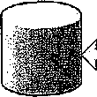
GIS Database

ADAM Attributes

With Businesses one type of Business may have several premises associated with it. Shown below is the type of structure which would be required in ADAM.
Business Information ■■

Business Name
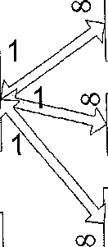
' Y i\ Main Category
Business \^\/ Secondary Category
V^ J Business Description
Business Location
Building Number Building Name Street Town County Postal Code
Premises
V
iil
URL-Business Image eGornmerce. Available ee.omrnerce.URL
Contact Details
Contact Number Phone Number Fax Number Email
Opening Hours
Day
Open Time Close Time
Business Event
Event Description Event Time Event Day Expiry Date

An issue here is that a Premise may have several businesses associated with it
In relation to opening hours the Business should have the ability use Mon-Fri or set as
individual days.
This is the same for Events
The main category and sub-category are associated to lookup lists
Shown in appendix 1 and 2 are the Main Current categories and sub-categories. These will be reviewed and revised.
Page 12 of 34

Mobhaile Porta! Design Document: Draft
To register a business the owner must first be registered as a Citizen.

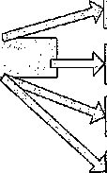
Register. Business
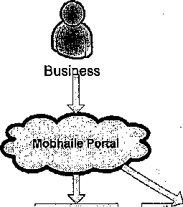
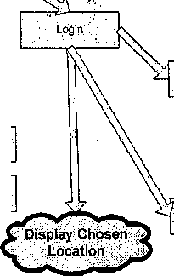
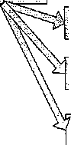


View'Profile
Enter Details';relating. . -toBusiness
Chppse primary :atid" secondary¹ categories
Enter details associated with^remises ..
. ehdose?.Grbups iWFavountes;
Delete groups as favourites ■
.Show.RSSof Favourite Groups
IF
JL
3£
View/Zoom Area
3E
Choose Location of Business
Community .'Groups.
EditBOsiness • ..Detail's'''
Edit Citizen .Details
Change Citizen . Location".■'"
Cnarige Business "■". location

When the portal user registers a Business there must be a connection kept between the Business ADAM and Citizen ADAM structure


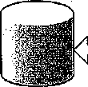
Citizens ADAM

The GUID of the Citizen would be stored in the Business structure. The Business owner when creating a business object enter details associated with the business
Business Name
Business Description
URL
Page 13 of 34

Mobhaile Portal Design Document: Draft
Business Image
eCommerce Available [Yes/No]
eCommerce URL
Choose a Main Category and Secondary Category and the enter details associated with the premises.
Building Number
Building Name
Street
Town
County
Postal Code ■ -
Contact Number
Phone Number
Fax Number ■<
Email
Days Open Open Time Close Time
For an Event
Event Description Event Time Event Day Expiry Date
As part of adding details to a business there will be a need to allow a business add an event to a business. Through the administration of the business the owner can log in and add a description, time and day. The owner can also add an expiry date, that is, how long this event should be available to be searched. When the expiry date has elapsed it will b deleted from the database.
Page 14 of 34
Mobhaile Porta! Design Document; Draft

Connection
GaomatryTypa

(■DescriptiveName : siring ■Collection Featured ass : object
K3MType : string 4-OGCTypB : siring

♦VerifyConnection!): ^{D}°^{o1}
Attribute

_1Z
'—):
SQLConx
*ServerName: string tSQLdb: string TSQLuld: string SQLpwd: string
JaL.
Feature
+Nhkib : string +G.eometryType: object ♦Attribute: object ♦Visualisation: object -SQLSearch; object Report: object
+VerffyFealure(|: boot +Bui|dStoredProcedures(): void
*SQLFtaldName: string ♦SQLFIeldType: string ♦TransformTo: string ■NiceName: string +N1 ceFonnal: siring
Visualisation
+N ice Name : string tThematicFleld : object ♦Query: object
Query
+Nice Name : string +Tooffip : object ♦IsMotspot: bool fAtlribute Filter; object -Symbology: object

SQLSearch

■Name: string •StoredPiocName : string -AttributeFlller
Rspor
♦NiceName : string ■♦-Attribute: object
''~S
Attribute Filter
-•-Attribute: object K3perator; string *DefaultVaiue: string ♦Predicate : bool

Tooltip
♦Ordered: object

BaseSymbology
4-GenerateGMTooltipO : string

Colour : int

X£_
TextSymbology
v^
GMSymbol
M^
Line Symbology
PolntSi m pi eSymbology
_i!i_
Poly Symbology

FonlName : string f FontSize: string -FontWaight: string
♦Symbol FilePath: string ♦SymbolName: string +VerifySymbolO: bool
+■Weight: siring +Decoration: string
♦Size'. string
♦FillColour: int ♦FillStylB : string

Page 15 of 34

Mobhaile Portal Design Document: Draft

Create"?-'" -Business':.
Create a.Citizen.

Create-Business; betails|in;Ab^M'
Create Citizen. Detail in ADAM

/GUlD/a^tb'ni'atipally/" ■ "■Created^ :';
GUID .automatically ■ ■■ Created¹ "

■iigitise;gusiriess
Digitise Citizen

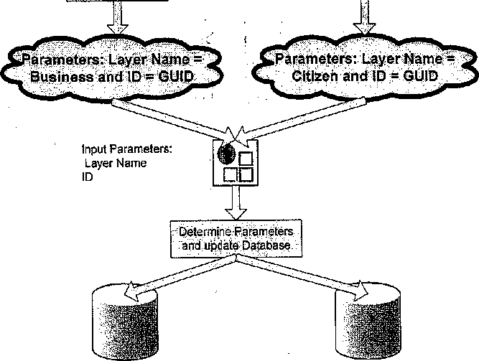
Digitising Web Service

Business iGlS Database

Citizen iGlS Database

For the Business Module to extract information from the Business database and return this information a Web service will need to be designed and coded for the business database
Shown are the functions required in the Business web service
Page 16 of 34

Mobhaile Portal Design Document; Draft
| . .u'itWStJb-. - Uol'of Burinawst ' Extract Builnms "S.»|chfsr' ■ ■ .Extract Business . ' ■y' "■ - ■: ■: ■ ':.;_■^{v} ■;■.,■ ■ ■:_{t}"'--'\:-' ;
-ciittgeifM"train ' ,;fromS™iri»ty Dsta««forIrutlvidunl -.BuslnMsby ' Details "hMmJvldutir ■*%*■..- iEdrt'Busini'sV r^^{fc}W°r :-.■swroh.pj.
Business Web Service I °'^.™^{l1}»",'\j|
3f§||i _ : : ■ ". ^ i/":" D^,^8si^Bii<^b:,!f,..".-:;-,/
5. Management Tools
The eChampion will require tools to allow them to delete citizens and businesses from the database where appropriate.
Page 17 of 34
Mobhaile Portal Design Document: Draft
6. Web Mapping
When the Portal User accesses the Mobhaile web site spatial information will be required to be gathered and presented to the user. This information will come from several sources be it Local Authority or third party. There should not be the need to replicate this data from its source to a central server. The planned architecture would be to use Web Map servers as a service around the data to allow mobhaile access this data and combine into a single map which the portal user can access.
Page 18 of 34
Mobhaile Portal Design Docunient: Draft


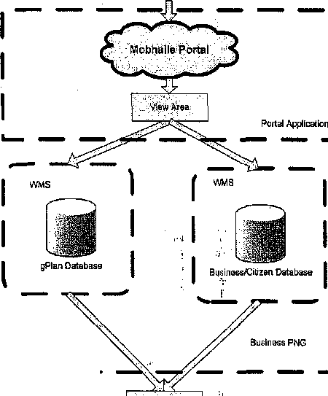
Citizen

Map PNG Towntand PNG Planning PNG
Combine :Layers

Citizen.
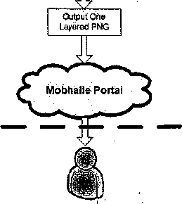
Portal Application

Web Map Server
A web feature server provides an image of a map for a requested area. "Layers" are advertised and can be requested individually or as a composite map. By returning the map as a Raster image, no additional software is necessary on the client side, just a web browser. The WMS consist of 3 simple interfaces.
- GetCapabilities - Provides information about what features are available
- GetMap - Provides the resulting map from the query
- GetFeaturelnfo - Provides additional information on a feature
Page 19 of 34

Mobhaile Portal Design Document: Draft
GetCapabilities
Provides information about what a server can do, what data layers, it can serve, formats available etc. For example
http://portal.mobhaile.ie/mapserver.aspx?wmtver=l. 1.1 &request=capabilities
Response will be in XML
Get Map
Provides clients with pictures of maps. Key parameters are
- Layers
- Styles
- SRS
- BBox
- Format

Request Parameter | Required/Optional | Description
REQUEST=GetMap | R | GetMap request.
VERSION=version | R | 1.0.0, 1.1.0. or 1.1.1.
l_AYERS=layer_list | R | Comma-separated list of one or more map layers. Values in list correspond to the layer id in the AXL file. Optional if SLD parameter is present in request.
SRS=EPSG:id_code | R | Spatial Reference System code that the map is returned in. Codes correspond to coordinate system id codes found in the ArcXML Programmer's Reference Guide.
BBOX=minx,miny,maxx_{l}maxy | R | Bounding box corners (lower left, upper right). Values must be in SRS units.
WIDTH=output_width | R | Width in pixels of resulting map image.
HEIGHT=output_height | R | Height in pixels of resulting map image.
STYLES=style_list | R | Comma-separated list of one rendering style per layer. Use null value for default rendering, or use style name from Capabilities response or SLD document, if applicable.
FORMAT=output_format | R | Output format of map. Valid values are listed in the WMS Capabilities Document's GetMap
Page 20 of 34

