ATTACHMENTS
Mobhaile Portal Design Document: Draft
Design of a Portal Site
Page 1 of34
Table of Contents
- Tasks Required 3
- Design of Mobhaile Front-End 5
- Citizen Module 7
- Business Module 12
- Management Tools 17
- Web Mapping.... 18
- Digitising web Service 23
- Business Functionality 25
- Public Buildings ; 29
Appendix 1: Main Categories 30
Appendix 2 : Secondary Categories 31
Appendix 3: Actions ., -. .33
Mobhaile Portal Design Document: Draft
1. Tasks Required
The tasks required in relation to designing and coding the portal site as set below.
- Design of Mobhaile front-end
- Hardware and Architecture
- Citizen Module
a. Backend Citizen Profile
i. SQL ii. ADAM iii. .NET code to Manage information
- Registration
- Viewing Details
- Editing
- Deleting
b. Design of Citizen GIS Object
c. Design of Citizen -1 am interested in here
4) Business Module
d. Backend Business Profile
i. SQL ii. ADAM iii. .NET code to manage information
- Registration
- Viewing Details
- Editing
- Deleting
e. Business Web Service
f. Design of Business GIS Object
g. Design of Digitising for Businesses
- eChampion Management tools for Citizen and Business
- Investigation of Categories to be used in Mobhaile
- Web Mapping
h. WMS for gPlan Database
i. WMS for Mobhaile Database
j. Digitising Web service
k. Creation and combination of PNGs
8) Functions for Business
I. Reporting for Business i. From Categories ii. From Spatial Object m. Business Events
i. Adding an Event ' ■ 'f '."';■. ii. Searching for an Event' n. Citizen Logged in
i. Show me nearest Business o. Freetext search on Businesses
Mobhaile Porta) Design Document: Draft
9) Public Buildings p. Digitising q. Adding to Portal
i
Page 4 of 34
Mobhaile Portal Design Document: Draft
2. Design of Mobhaile Front-End
First screen should be a Splash screen displaying Ireland with some information about Mobhaile. This screen would be the first entry point "until the Citizen is registered.

Information
About Mobhaile
JO¹
The user could then click on the County they are interested in which will bring them to an
interactive map. . i A ■
TOOLBAR

TEXTUAL INFORMATION
SPATIAL MAP

Toolbar
This toolbar will allow the citizen to Login, Register and view and edit their own profile.
Through the register tool, they will be able to enter details which will allow the user to be
registered as Mobhaile Portal users.
They would be able to enter some details relating to themselves. They would also
associate themselves to an area. They would; work by clicking on the map and a XX m
squared would be associated to this user. . , ;\
The login tool would allow the user to login and the map would zoom to the area set in
their profile. !
Page 5 of 34

Mofahaile Portal Design Document: Draft
The profile tool would allow the user to change their profile details including which area
in the map they are associated to. '■
Textual Information
This will display information on categories related to Business and Community information. When the user clicks on a category a list of sub-categories will be displayed. From these sub-categories a list of objects will be displayed. The citizen can then view details on these categories and view them in the Textual information area or click on a button to display the object in the map.
Spatial Map
This area will display information in relation to spatial details. This area will display a
map displaying spatial information in a PNG format, a legend defining what the spatial
information will look like and zoom levels displaying at what scale the map will be
viewed.
The zoom levels will have 7 scales ranging from county level through DED to street
level. When the user enters the web site through the profile the map will zoom to set
scale to define the area they are assigned to.

MAP \ | ZOOM LEVELS
MAP \ | LEGEND
The Legend will display a graphic representation of the spatial entities which appear in the map. Through the legend, layers in the spatial map can be switched on and off. The map window will contain the spatial information designated for the current scale. The citizen will have the ability to pan in 8 directions. This movement should ensure that even as the citizen moves outside their functional area the spatial information will still be displayed.
When the user is at county level they should be able to search by Townland and zoom to that townland when located. This may be extended to a "Web Gazetteer Service" which is an OGC compliant service
Page 6 of34
Mobhaile Portal Design Document: Draft
3. Citizen Module

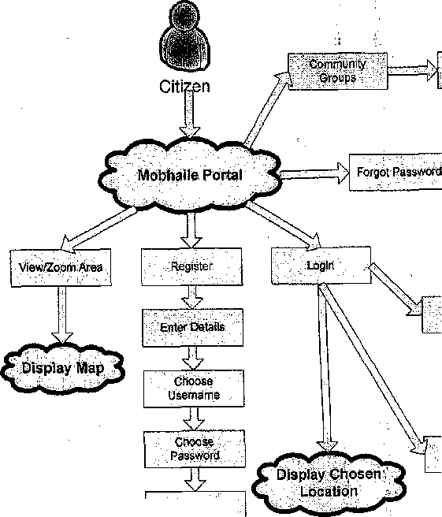
IE

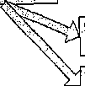
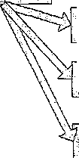

■■Se^cftiQiiptiRs'^'
-;,.--".,.■-.".- . k :; .-Register
View^rofil^ :: —v - -BusiliesS
Edit details
Change Location
Choose Groups as Favourites.
View/Zoom Area
Delete ;;grqups; as Favourites
■ -" Shwft.-RSS'bf.'-Favourite Groups
Choose Location
Cbirirrjuriijy" GrOUps'

There is a need to store Citizen Information for users of the Mobhaile portal. The objective will be to store the Portal users attribute data in ADAM and active directory and store the iGIS component in a GIS database. There would be a link between the ADAM business instance and the instance in the GIS database.

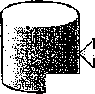
GIS Database

ADAM Attributes

Page 7 of 34

Mobhaile Pbrtal Design Document: Draft
The ADAM structure for the Community Members will be used and the Portal user will be a subset of this. Currently there are three containers in ADAM. Citizens, eChampions and Superuser. A new Container titled/'Portal user" will be added.
When a citizen first registers as a portal user they will be placed into this container.
Details Stored in relation to a Citizen when registering will be Surname First Name Address Email Address
The user will then be able to choose username and password. This will check across all containers for unique usernames.
The user will also have the ability to zoom to an area, click on a "Choose Location" button and assign this area within XX meters of the point as their Assigned Login location.
When the user can edit their profile they will have the option to edit all details associated with the Community structure, that is, add PPSN etc.
When a PPSN is added they will be promoted to the "Citizens" container which means that they will be searchable from the Community groups section.
By default a Community registered member will have a login for the portal. This user will then have to view their profile and select an area they will be associated to.
When a Portal User logins the portal will switch to the Location they have chosen. They can then change details associated to their profile or location. The portal user will also be able to search through the community groups as select those that would be saved as favorites. Extra attributes would need to be added to the Citizen ADAM structure to accommodate the storage of the Community Group favorites.
An RSS feed to then aggregate the Favorites into one feed which the user can view.
The GIS Structure will fit into the GIS Object Model as set down by the Corporate GIS team.
Page 8 of 34
Mobhaiie Portal Design Document: Draft

Connection
GeometryTypa

♦DescriptiveName : string -Collection Fa alureCI ass: object
*GMTyps; string KJGCTypa: string

(-VerifyConnaction0 : boot
Attribute

_iZ
SQLConx
(■ServerName: string (■SQLdb: string (-SQLuid : string -SQLpwd: string
Feature
t-Name ; string tGeometryType; object ►Attribute: object (■Visualisation: object ■SQLSearch : object -Report: object
(■VerifyFeaturel): booi (■BuiidSlc red Procedures)): void
(■SQLFietdName: String (■SQLFIeldType: string (■TrartsformTo: string ■NiceName : string t-NiceFormal: string
(■NiceNamo; string (■ThemalicField ; object (■Query: object
Query
♦NiceName, : string +ToolTip: object +lsHotspot:bool (■AttributeFillar: object Symbology', object

-Name : string -StoredProcName : siring ■Attribute Filter
Repor
AttributeFMter
+Attribute: object (Operator: string (-DetaultValue: string (■Predicate: bool

(-NiceName: string (■Attribute: object
Tooltip
(■Ordered: object

Base Symbology
(■GenerateGMTooItipO: string

Colour : in I

TextSymbology
(■FontName: siring (■FonfSae : string ■FontWeight: string
vs
GMSymbol
(■Symbol File Path ; string (■SymbolName : string (■VerifySymbolO : bool
LI no Symbology
(■Weight: string ^Decoration ; string
PointSlmpl e Symbo I o gy
tSize ; string
Poly Symbology
+FillColour: int +FillStyle : string

The Spatial data will be stored as a Point object in the citizens table. When a user
chooses a location, the "Digitising Web Service" will be called which will take the name
of the Layer "Citizens" and the GUID of the citizen and create an instance in the citizens
table.
When the citizen logins, the table will be checked and the map will zoom to show the
area chosen by the portal user. Each portal user can only have one instance of the citizen
table.
Page 9 of34

Mobhaiie Portai Design Document: Draft

' ;£f§aj&a:::.
Create a. Citizen

■;Great|iBusip^sr: ;'D^ij^i(j;^!|^ji
X ;.Gpe:a1e;Gitize^?-;

GUiD/automatically " ' created ■';.
GUID automatically Created

Digitise. Business.
Digitise Citizen

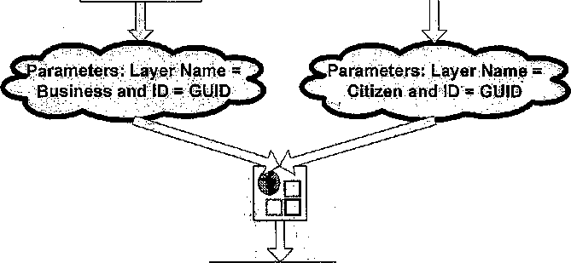
Input Parameters: Layer Name ID
Digitising Web Service
Determine Parameters and update Database

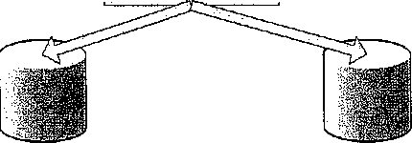

Business iGlS Database
Citizen iGlS Database

A web service should be designed and coded to interact with the citizen database
Page 10 of 34

Mobhaile Portal Design Document: Draft
Client

<Z_

:A<to Citizen
Edit Citizen
■ Delete Citizen

Citizen Web Service
'-dutput'R'e'stiltsias;'-.



1^1


.'Oatpuf'R'esulteas-XML'.

Citizen Database
Page 11 of 34

